《00015英语（二）》考试答题技巧

做题步骤及技巧：
1.选择题：阅读选择、阅读判断、填词补文：
首先是看一遍考题及其选项，分析考题的题型以及其出题意图(主要是关键词)是考(问)什么内容的，划出各选项的关键词及写出其大意;其次了解短文的大意或中心思想;再次是根据考题的题型和关键词以及其选项的关键词选择选项。（认真答题，选择题需要在答题卡上用2B铅笔图选项）
3.完形补文：根据题意写单词，一般单词后面加后缀就可以（一定不要空题）
4.作文部分，作文总共占了30分，最好是背几篇好一点的范文，或者实在不会的可以到前面的阅读理解找句子写上，单词写工整，最少要写八排以上句子，150个词汇(作文只写几句话或空白题就无法拯救！！)。
答题卡
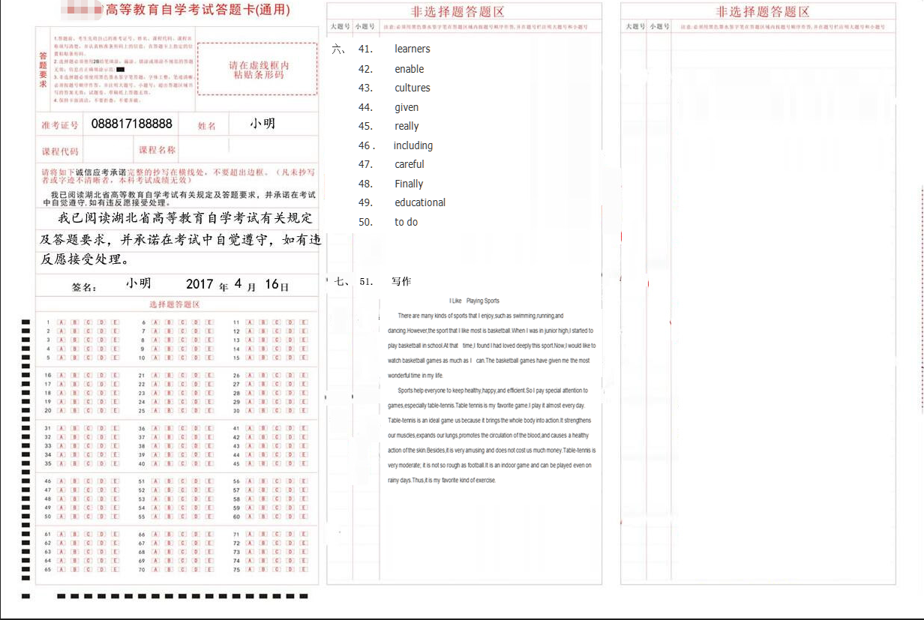

往年试卷及答案
学员可以提前了解相关题型，自己需知如何做题，提前有个印象
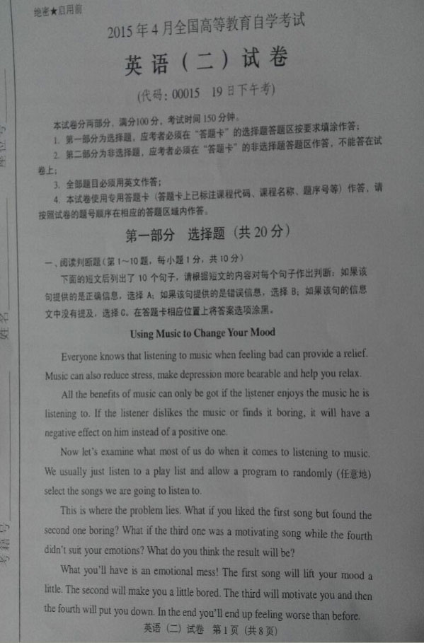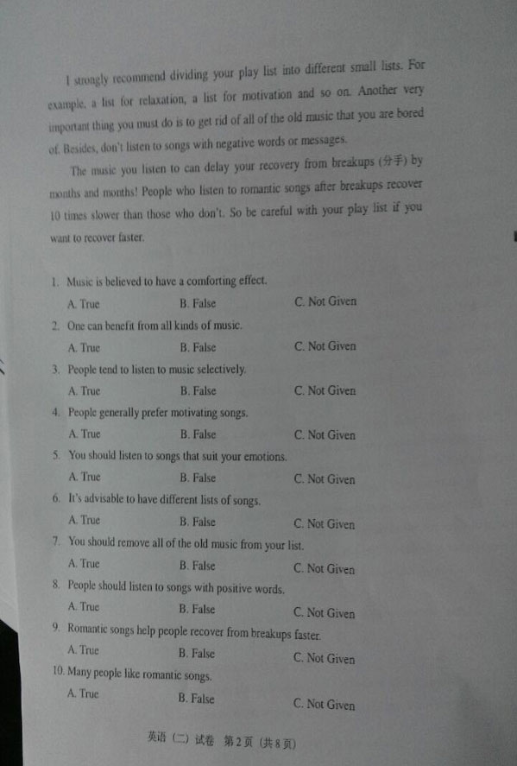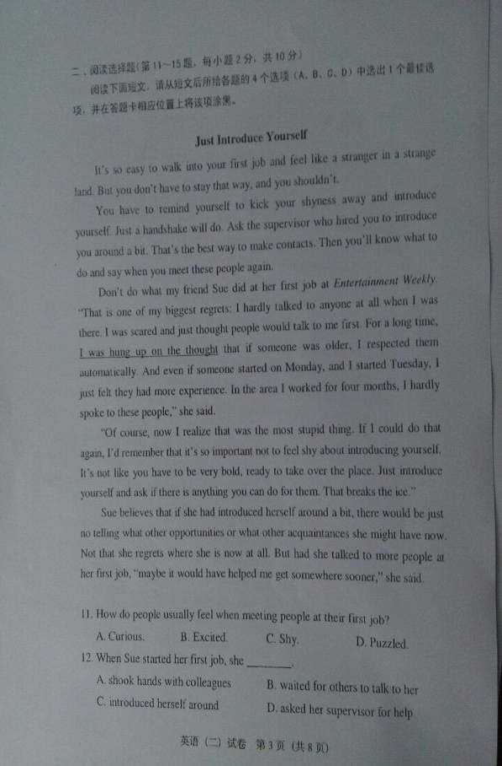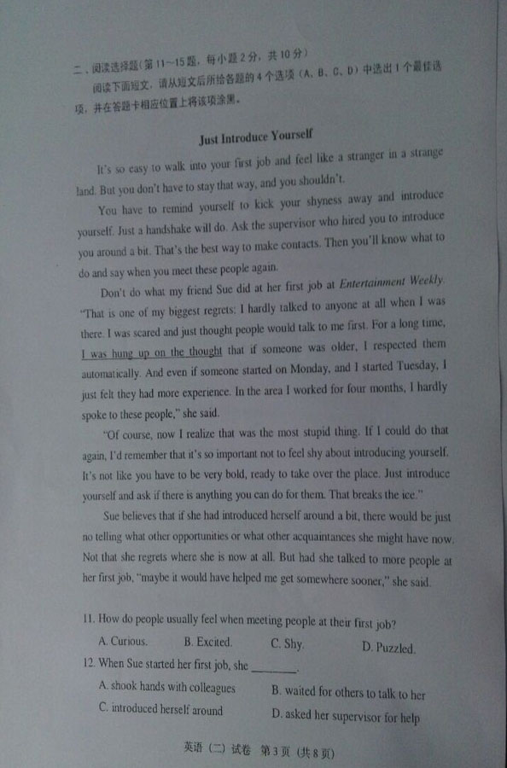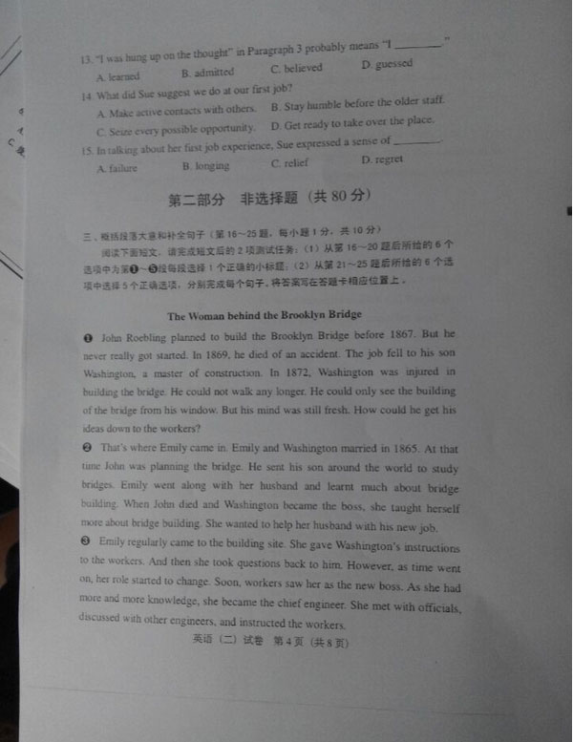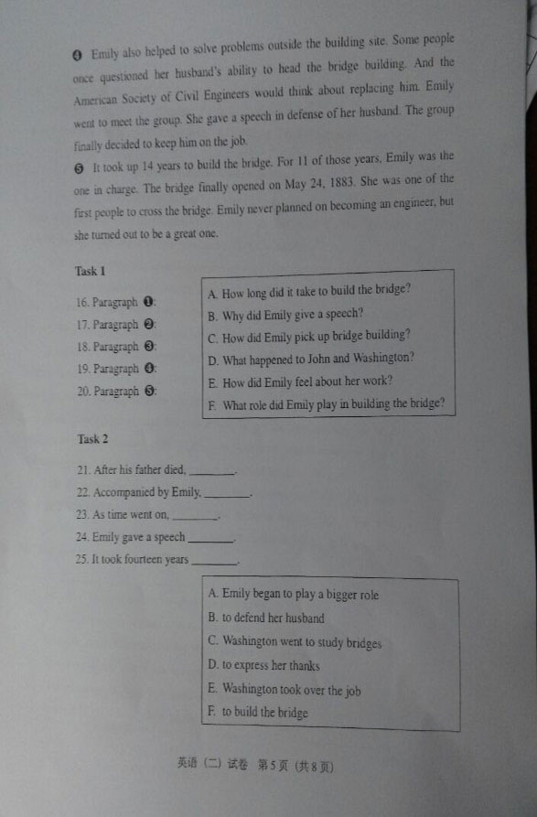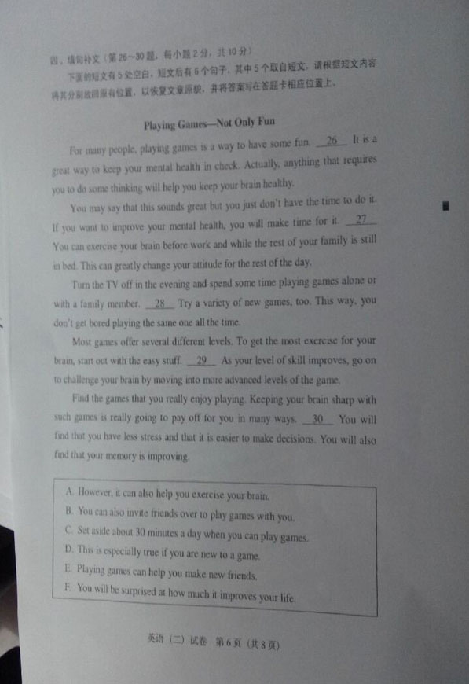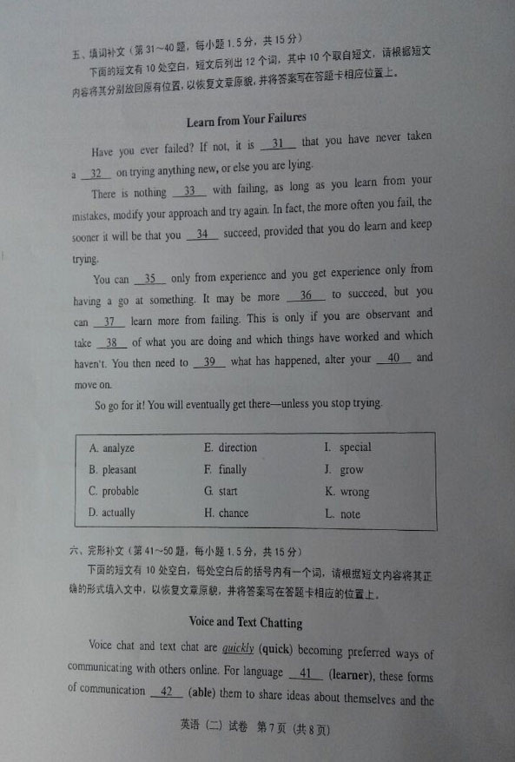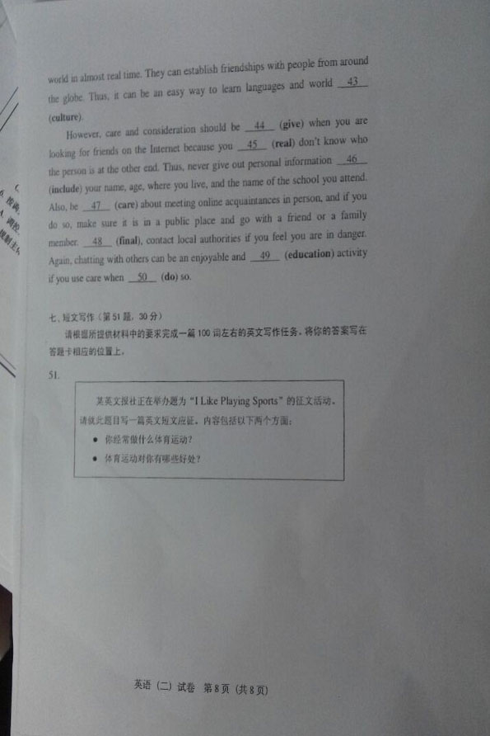
历年试题答案：
1.true 2.False 3.Not Given 4.False 5.False 6.true 7.False 8.true 9.False 10.Not Given 11、shy 12、waited 13、believed 14、make 15、regret 16what happened
17.选(How did Emily feel....)
18.选(What role did Emily play ...)
19.选(How did Emliy pick up bridge...)
20.选(How long did it take to build the bridge?)
21.选(Washington took over the job...)
22.选(Washington went to study bridges ...)
23.选A(Emily began to paly a ...)
24.选(to defend her ...)
25.选(to build the bridge...)
31.B pleasant
32.H chance
33.k wrong
34.F finally
35.J grow
36.C probable
37.D actually
38.L note
39.A analyze
40.E direction
41 learners
42 enable
43 cultures
44 given
45 really
46 including
47careful
48 Finally
49 educationa l
50 to do

51.写作：I LIKE PLAYING SPORTS
There are many kinds of sports that I enjoy,such as swimming,running,and dancing.However,the sport that I like most is basketball.When I was in junior high,I started to play basketball in school.At that time,I found I had loved deeply this sport.Now,I would like to watch basketball games as much as I can.The basketball games have given me the most wonderful time in my life.
Sports help everyone to keep healthy,happy,and efficient.So I pay special attention to games,especially table-tennis.Table tennis is my favorite game.I play it almost every day.
Table-tennis is an ideal game us because it brings the whole body into action.It strengthens our muscles,expands our lungs,promotes the circulation of the blood,and causes a healthy action of the skin.Besides,it is very amusing and does not cost us much money.Table-tennis is very moderate; it is not so rough as football.It is an indoor game and can be played even on rainy days.Thus,it is my favorite kind of exercise.

